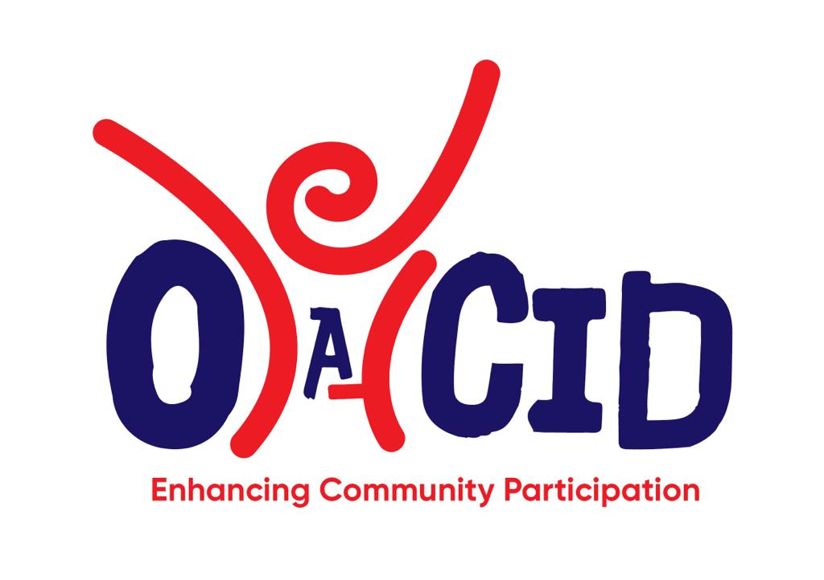

OGABWA COMMUNITY INITIATIVE FOR DEVELOPMENT (OACID)
(LTD BY GUARANTEE)

COMPANY PROFILE

CONTACT PERSON:

Daniel Ogwang Abwa
Managing Director
P.O. Box 119573
TEL: +256 772860060, +256 703897715 (Whatsapp)
Email: ogabwacid@gmail.com
KAMPALA - UGANDA

BACKGROUND OF OACID
Ogabwa Community Initiative for Development (OACID) is a capacity building Institution that was established in 2020 as a voluntary venture involving a team of expertise in different developmental interventions with the need to address the gap in intervention strategies by most civil society organizations and non-governmental organizations that often results in inability to sustain the impact of most development interventions among the community. As a result of the need to formalize its operation, OACID officially got registered in May, 2023 by the registrar of companies as a company limited by Guarantee without share capital (Registration No: 80034190088640; Certificate of Registration is attached as annex 1). The initiative was engineered by a team of professionals with over 15 years of experience in community development as a basis for continued support in community transformation and development.

LOCATION
OACID Head office is located at Luteete, 8kms along Kampala - Gayaza Highway with field office in Lira that coordinate operation in Northern Uganda and a Satellite coordination centre in Mbale City for Eastern part of Uganda.

Vision, Mission & Core Values

OUR VISION
To promote rural development through innovations and community led participation for sustainable impact


To promote community participation in development through business development support services, rural finance support services, climate change adaptation, ICT Innovations, Research and Development and creation of partnership for income generation and sustainable livelihood

CORE VALUES
- Mutual Respect: - OACID being an organization with community empowerment, implements its activities with respect for its clients, partners and all who support the drive to poverty reduction.
- Accountability: - OACID believes in accounting to all its clients, members, partners and stakeholders in a transparent manner and availing them with reports of its activities.
- Team Work: - The staff and management believe in achieving its goals and objectives through working as a team with its partners & clients without any segregation.
- Professionalism: - In serving its clients and members, OACID promotes and exhibits a high level of professionalism to attain partner/client’s satisfaction
- God Fearing: - OACID team believes in the existence of supernatural power beyond this natural world and puts its faith in the almighty God to guide their objectives, irrespective of religious affiliation.

COMPANY OBJECTIVES:
- To provide business development support services to individual’s farmers, farmer organizations, micro small and medium size enterprises, community empowerment associations, and both public and private sector entities.
- To provide services that support and promote entrepreneurship development in the interests of informal, micro, small and medium enterprises.
- To provide services that promotes access to and usage of microfinance and rural finance through capacity building trainings, linkages and continued mentorship.
- To promote agricultural value chains development including climate smart agriculture, trainings and linkages for increased production and productivity of agricultural products.
- To promote climate change adaptation through promotion of mixed use agro-forestry system, restoration of degraded landscape and watersheds
- Promote Information, Communication and Technology (ICT) in operations and value chain development while leveraging on the power of technology system and application to achieve impact and cost reduction.
- Carry out research and development that promotes effectiveness, efficiency, reliability, validity and greater impacts
- To collaborate with development partners, Government and Non-Governmental Origination in facilitating community participation for sustainable development

SERVICES OFFERED:
In carrying out our services, OACID is set out to contribute towards Poverty Reduction through enhanced community participation. The company offers the following services;
Business Development Services to individual’s farmers, farmer organizations, Micro Small and Medium Size enterprises, community empowerment associations, and both public and private sector entities.

.
Microfinance Support Services. Trainings and technical guidance for the Village Savings and Loan Association, Savings and Credit Cooperative, etc in areas of Governance, Operations, Product and systems development, etc.
Consultancy Services in areas that includes;
Business Plan Development,
Business Skills trainings & Manual Development.
Agricultural Value Chains Development.
Organizational Development
Farmer Institutional Development
Research and Development

OUR PARTNERS

OACID works with both private and public sectors including national and international partners with the mandate of supporting community empowerment programs for development. Through its promoters, OACID have supported Karamoja Women empowerment initiative in partnership with UNDP, Government of Uganda and Lead Farmers through commercial production of oilseed crops. Promoted business growth and job creation through BDS support to Agribusiness SMEs in partnership with UNCDF START Facility, Strengthened the Supply and Quality of affordable BDS in Northern Uganda in partnership with Friends Consult and GiZ.

OUR STRATEGIES TO DELIVER SERVICES:
In fulfilling our mission, OACID partners with Government Ministries, Departments, Local, National and International Organisations/Institutions to provide subsidised and sustainable services to the vulnerable communities and also promotes participatory approaches while adopting community driven development approaches of enhancing competitiveness, buy-in, ownership and sustainability as a strategy. These include;
- Identifying and promoting livelihood options and initiatives that are within the community and local environment;
- Promoting technologies and best practices that is usable, adoptable, culturally acceptable and environmentally friendly.
- Continuous research and gathering information from time to time to improve on the existing ones.
- Beneficiary follow up and dissemination of new relevant information that enhances improvement and further development of the community.
- Incorporation and promotion of specialisation, market driven and value addition in delivery services.
- Institutional development and linkages between programmes, through collaboration partnership between the micro, small and large enterprises, as well as lobbying and advocacy role.
- Client orientation through quality service delivery that meet client expectations and needs (satisfaction);
- Demand driven services, bearing in mind differences in capacity of clients, and convenience in the provision of services to clients in terms of access, and timeliness.

METHODOLOGIES AND APPLICATION WE USE
We use customised modules in capacity building services, and tailor - made services to meet client needs which are based on needs assessment. We make use of participatory and non-participatory methods in service delivery where appropriate; interactions and sharing of experiences, collaboration and networking, Appropriate-pricing mechanisms are adopted. OACID Team have on several occasions been contracted as Individual Consultant / Contractor by UN Agencies, Government Agencies, both Local and International Non-Governmental Organisation to implement development programmes to their satisfaction. During trainings, we adopt the Learning Pyramids to strengthen adult learning techniques and ensure skills retentions.

TARGET GROUP FOR OUR SERVICES
OACID works with different target groups in the both rural and urban settings in fulfilling its mission, vision and objectives, these are
- Non-Government organisations; including Civil Society Organisations, Community Based Organisations, national and international organisations, umbrella organisations
- Private Sector Institutions; including the individual framers, business owners, group enterprises including farmers organisations and institutions, Micro Small and Medium Enterprises, Agri-SMEs, microfinance institutions., to mention but a few.
- Public Institutions; including the Local Governments, the central government and ministries, public advocacy networks.
- Community groups; including organised women groups, farmer groups, youth groups, common interest groups, credit and savings groups, special interest groups such as refugees and host community, HIV/AIDs affected and infected groups and People with Disabilities.

COMPANY CAPABILITIES AND RESOURCES

Policies and Operation Guidelines

With the wealth of experience developed by the OACID Directors and the Company Senior Managers who have come together to utilise their expertise for a common goal, we have made extensive consultation with various consultants / experts and have developed policies and operation guidelines that are in place. The existing approved policies and guidelines are; Human Resource Policy, Procurement Guidelines and Method, Finance and Accounting Policy, Employee Code of Conduct, Conflict of Interest Policy, Document retention policy, Asset Management Policy, Board Recruitment and Selection Policy. Others include; Gender Inclusive Policy, HIV Work place Policy, Prevention of Sexual Exploitation and Abuse (PSEA), Prevention of Sexual Harassment and Abuse of Authority (PSHAA).

Human Resources

In addition to other professional staff, the company is managed by two Directors (Managing Director and Director for Operations and Coordination) under whose directorship, well trained, well experienced, self-motivated and well dedicated staff are brought on board based on the need for a particular project and are engaged for a duration of such project. The selection of staff is aimed at bringing on board experienced human resources to carry out any assignment /contract given to it with customer satisfaction being top priority. The two Directors are technically supported by well qualified and experienced managers (1) Monitoring, Evaluation and Learning Advisor; 2) Economic Empowerment Specialist, and; 3) Agribusiness Development Specialist)
Below is the summary of competence for the Management Team:

Mr. Daniel Ogwang Abwa (Managing Director)
Daniel holds a Master’s Degree in Business Administration and a Bachelor’s Degree in Public Administration majoring in Human Resources Management, Postgraduate Certificate in Performance Management in Organisation, Certificate in Strategic Human Resources Management; ToT Certificate in Financial Literacy, Certificate in Project Planning and Management and Resource Mobilization, Monitoring & Evaluation, Entrepreneurship Development and Village Savings and Loans Associations. Daniel is currently pursuing a PhD in Management Course from Texila America University.
Daniel has over 24 years of practical experience in organization management, program management, project coordination, etc; having worked for 10 years in Public Sector (Bank of Uganda and Ministry of Local Government) and over 14 years with Non-Governmental Organizations including International NGO; implementing Livelihood programmes; Financial Inclusion, Youth and Women empowerment program, and agricultural value chain, among others. Over the years, Daniel have developed excellence in areas which includes but not limited to: Program coordination, grants management, program implementation and monitoring of projects; Providing guidance and technical assistant for agricultural value chain and enterprise development to local governments and private sectors across Uganda; provision of Business Development Service, business plan development for groups and individuals; Facilitating market linkages for MSME products and value chain development; Training & supporting the development of Micro Small and Medium Enterprises; Coordinating & conducting business skills trainings for individuals, women and youth groups; Providing technical assistance on selection and managing of livelihood projects; Proposal writing and resource mobilization; Fostering the development of partnership and synergies with development partners;
Daniel worked with different organizations, including Public Sector, Private Sector Development Companies and Non-Governmental Organizations. In terms of partnership coordination and satisfaction; Daniel has experience working with different donors including; USAID, UNDP, UNCDF, UNIDO, CSF, CRS, CARE International, Stromme Foundation, MAAIF, MWE, AfDB, World Bank, IFAD, GiZ, etc.
Daniel is an experienced Business Development Specialist and he will also head the Business Development Services component of the services provided by OACID.

Mr. Nelson Richard Tasenga (Director of Operation)
He has a Masters of Business Administration majoring in Finance and Accounting, a degree in Commerce majoring in Accounts, a diploma in Business Education. He has acquired certificates in the following; Management and Supervision of personnel, Portfolio Management, Advanced Supervisory Management, Lending to Small and Medium Enterprises, Essential skills for Micro Finance Managers, Business Planning and Financial Modeling, Agricultural and rural lending, Task oriented supervisory management, Branch management, Quality customer service, Village Savings and Loan Associations. Nelson is a certified ILO trainer of Gender and Entrepreneurship Together, Building Women Entrepreneurs Associations, Start and Improve your Business (SIYB) and Disability Equality Training. Nelson has also been involved in business Skills and Microfinance manual development over the years.
Nelson has over 12 years of practical experience in management and finance and has participated in various training which range from but are not limited to entrepreneurship development, business skill training, savings mobilization and credit management, project proposal writing, record keeping, management of small and medium enterprises, governance and management of micro finance institutions and cooperative societies.
Nelson has worked as a supervisor with Foundation for International Community Assistance (FINCA), Foundation for Credit and Community Assistance (FOCCAS) as the Operations Manager, Ministry of Local Government as the Financial Initiative Specialist and Acholi Private Sector Development Company Limited as a Chief Executive officer.
Nelson is the ILO certified Gender and Entrepreneurship Together (GET Ahead) Master Trainer and also an experienced Financial Inclusion Specialist. He will also head the Financial Inclusion Services component of the services provided by OACID.

Mr. George Wycliffe Bwire (Monitoring, Evaluation and Learning Adviser)
Wycliffe is highly qualified M&E Specialist with Master of Public Health (Population and Reproductive health), Post Graduate Diploma in Monitoring and Evaluation and a Bachelor of Science in Demography and Population Studies. He had highly skilled in the areas of; Monitoring and Evaluation of development and Humanitarian Sectors, Knowledge Management, Accountability and Learning; Data Management, analysis and Research for both qualitative ad quantitative methods as well as descriptive and inferential statistical packages (SPSS, SAS, Stata and Data visualization using power BI and Excel), and; Programme / Project Design, project cycle management, training and capacity building management, reporting, problem solving and time management.
Wycliffe has over 12 years of experience in M&E work having worked with Light for the World International at the position of Monitoring Evaluation Research Learning and Adaptation (MERLA); International Institute of Rural Reconstruction in the position of Monitoring and Evaluation Manager, and with Plan International at the position of Program MERL Coordinator. In addition, Wycliffe worked for four years as Project Officers Livelihood and Microfinance with South Eastern private Sector Promotion Enterprises (SEPSPEL) and have therefore amassed experience in both program direct implementation and program monitoring and evaluation.
Wycliffe brings his wealth of experience in program management and program monitoring, evaluation, documentation and learning to OACID at the position of Monitoring Evaluation and Learning Advisor.

Mr. Davind Baguma (Economic Empowerment Specialist)
He holds a Master’s Degree in Business Administration, a Bachelor in Development Studies, and a Diploma in Project Planning and Management with wide range of short trainings in relevant fields.
An innovative economic empowerment expert with over 15 years’ experience in areas of financial inclusion, food security and livelihoods, skilling, building entrepreneurs and Agribusiness. David is an avid business coach that has worked with communities to build vibrant, sustainable businesses. In addition, he has experience implementing agile livelihoods models including building thousands of community savings groups some of which have graduated into SACCOs and have been linked to bigger financial institutions.
He is innovative and believes in creation of new unique ideas, and he is credited to be having a unique solution for every problem. He communicates effectively and makes sound decisions. He has track record in building and leading highly effective teams that achieve targets. He is hardworking and result oriented, self-driven, practical, honest and reliable with high level of integrity, able to work under pressure and meet tight deadlines.
David Bagume is the Economic Empowerment Specialist for OACID and we believe that our talent teams together with our clients will benefit a lot from the experience of David as he serves the organization at the position of Economic Empowerment Specialist.

Ms. Mary Nanyanzi (Agribusiness Development / Gender Responsive Specialist)
Mary Nanyanzi holds a Master of Science in Agriculture and Rural Development, bachelor of Science in Agricultural Science and Entrepreneurship. In addition, she has the following training certificates; Certificate in Pedagogy, ILO – SYB (Start Your Business) Certificate, Certificate in Governance, Group Dynamics, Leadership and Team Building and Certificate in Professional Financial Cooperative Management, among others.
She is a part-time Lecturer at Uganda Christian University in the department of Agriculture, Faculty of Agricultural Science but her field experience is developed while working with International Institute of Rural Reconstruction (IIRR) as Regional Extension and Training Coordinator for Agricultural Value Chain Development Project of MAAIF; Agricultural Development Consultant at Green Consult Ltd; Cooperative Development Consultant at Association of Financial Cooperative Professionals of Uganda; Consultant for Digital Financing Project at Uganda Central Cooperative Financial Services; Consultant with World Vision for Cooperative Development under CARD Uganda Agribusiness Centre, and; with Uganda Cooperative Alliance (UCA) as the Regional Manager for DGD project ad vegetable Oil Development Project (VODP II).
With those experience among others not mentioned now, Mary has been actively participating in developing localised IEC and training materials and also practically training smallholder farmers on the use of improved climate-resilience technology as well as pre-and post-harvest handing techniques.
Mary is assigned as the Agribusiness Development Specialist and also responsible for the Gender responsive interventions under OACID.

Mr. Okiror Daniel (Finance and Administration Manager)
Daniel Okiror has an Advanced Diploma in Business Studies / Accounting, level II of Certified Public Accounting (CPA) and a Bachelor’s Degree in Procurement and Logistics Management. Daniel has got wide experience in financial management, having worked with different organizations including; Non-government organizations in implementing the United Nations funded projects but also being directly employed by two United Nations agencies UN-WFP (United Nations World Food Programme) and UNICEF Uganda.
Daniel worked at the capacities of Finance Officer with International Institute of Rural Reconstruction in Moroto, Programme Assistant with UNICEF Planning, Monitoring and Evaluation Unit at Country Office Kampala, Finance/Admin Assistant with UN-WFP in Moroto, Finance Administrator with JRS (Jesuit Refugee service) Yei S. Sudan, Senior Storekeeper and Head of Section for UN Food and Non-food Assistance Warehouses with German Development service in West Nile refugee settlement Programme, a partner to UNHCR (United Nations High Commissioner for Refugees), UN-WFP and OPM (Office of the Prime Minister) to 80,000+ refugees from S. Sudan, DRC, Kenya and Ethiopia settled across West Nile-Uganda and also as Accountant to Inter-Aid Uganda Re-afforestation project in Koboko that was established following environmental depletion from refugee emergency influx.
With the above exposures working with different high level organizations, Mr. Okiror has developed experience in support and programming functions such as financial budgeting, accounting and reporting, procurement and departmental purchases, warehouse, storekeeping and supplies distribution to different categories of intended beneficiaries, fleet / transport management including planning staff travels, fleet service schedules and maintaining Assets registers for equipment from different donors, own agencies and other partners contributions. Work planning, programming, partner agreement negotiations, report analysis, implementation evaluations and working with a diversity donor agency.
With the wide range of experience and maturity, Mr. Okiror has demonstrated ability to manage function of Sound Financial system and procurement processes. Consequently, he is assigned the Finance and Administration Manager for OACID with the role of financial, administration and procurement management.

ORGANISATION STRUCTURE
MANAGING DIRECTOR
Monitoring Evaluation and Learning Advisor
Finance and Administration Manager
Economic Empowerment Specialist
Project Managers
Project M&E Officers
BOARD OF DIRECTORS
Logistics and Administration staff
Project Officers
DIRECTOR OF OPERATIONS
Agribusiness Development / Gender Responsive Specialist
Community Based Trainers / Facilitators
Project Accountants
Directors (Strategic Level): Charged with strategic management and ensuring that the organization achieve its vision
Senior Managers: This level combine both operational / technical managerial level and they are referred to as Senior Manager
Middle Managers: The Project Managers falls under Middle Managers and attached to specific project to offer technical and managerial role to respective projects
☞
☞

☞

☞

Officers’ level: They carry out day-to-day management of their respective projects and supervises Field staff. This level includes Project Accountant as well
☞

Support Staff: These include field-based facilitators, Account Assistants, Drivers as well as the Security.

ORGANISATION CERTIFICATE OF REGISTRATION

